- Bluebook Page59 August 2019 Variant Five examination:

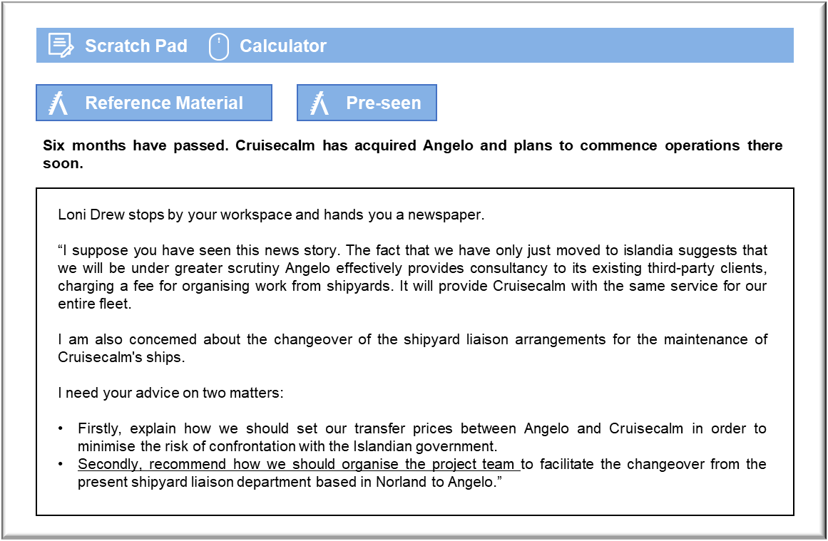

MANAGEMENT CASE STUDY AUGUST 2019 EXAM ANSWERS

Variant5 Task3
These answers have been provided by CIMA for information purposes only. The answers created are indicative of a response that could be given by a good candidate. They are not to be considered exhaustive, and other appropriate relevant responses would receive credit.

CIMA will not accept challenges to these answers on the basis of academic judgement.

Requirement 1: Transfer prices
We need to be clear about what Angelo is actually doing for the group as a whole, otherwise it will be difficult to defend any transfer prices on the basis that they reflect. The company is acting as a consultancy and intermediary between Cruisecalm and the third-party shipyards that are doing the construction and repair work on its fleet. There could be scope for misunderstanding by the Islandian Government if Angelo is acting as an intermediary in major contracts without actually earning a great deal of money itself .
The fact that Angelo conducts work for third parties suggests that it should charge Cruisecalm on the same basis as its external clients. That would suggest that there is a sound commercial basis for the pricing policy and, so, it would be more difficult for the Islandian Government to argue that the company is under-pricing sales to fellow group members. Historical evidence that Angelo has used this pricing model since before it became a member of the Group will further strengthen this argument. It would also be consistent with the guidance set out in the OECD’s 1994 guidelines on transfer pricing.
If Cruisecalm receives any form of discount from normal commercial rates, then the reason
should be both justifiable and clearly documented. If Angelo claims that is grants the discount because of the scale of business that it does for Cruisecalm, then it would be helpful if it could show that it makes similar concessions to other clients who provide that scale of business. The figures should also show that Angelo makes a realistic profit overall from the work that that it does for Cruisecalm, even after granting the discount.
Ideally, Angelo’s reported earnings will be sufficient to show that it is returning an adequate profit and paying an acceptable rate of tax in Islandia. Cruisecalm may have to consider whether it should pay slightly more for work done by Angelo in order to pre-empt an investigation by the Islandian tax authorities. It may be cheaper to pay a little more tax than might be strictly necessary, especially as the Government may be inclined to press any investigation in order to demonstrate that it is being effective in managing the local economy.

Requirement 2: Project team
The team should include representatives from Cruisecalm, from Angelo and from at least a
representative shipyard. Angelo will find it necessary to assume responsibility for implementing plans that were made by the existing liaison team and the yards that Cruisecalm has traditionally done business with. Angelo may not have had any previous dealings with the shipyards who have been contracted to do the work.
Cruisecalm should be represented by members of Marine Operations and Finance. Angelo needs to be briefed on the specific issues associated with the work that Cruisecalm’s ships require. It will also be necessary to discuss the budget for planned and committed work as well as agreeing the approach that should be taken to future work that will be entirely Angelo’s responsibility.
The project team members from Angelo should be senior managers from the business, ideally from the Board. Briefing Angelo’s senior staff should help to ensure that the changeover results in an environment in which the work entrusted to the company is conducted in an environment that reflects the Group’s approach to quality. Senior staff will also have the confidence to speak out on matters that concern them, even if they are dealing with senior managers from elsewhere in the Group.
It would be ideal if the project team could include the present head of the liaison team, even if that person is due to be made redundant. It would be a sound investment to pay that person to continue on a consultancy basis for the duration of the handover, to ensure that Angelo fully understands Cruisecalm’s approach to ship maintenance. The head of liaison would also be able to make useful introductions to contacts in shipyards and in the engineering departments aboard ships.

